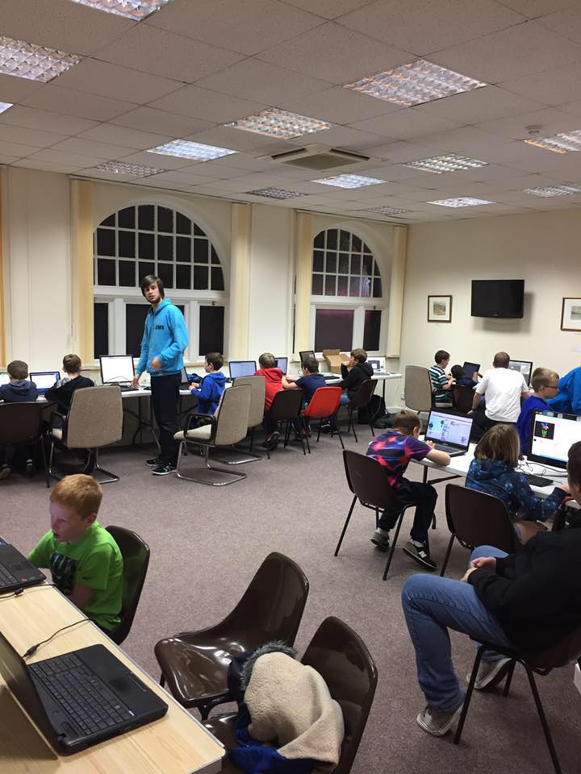

|  |
| --- |
| Volunteer Report |
| By William Taylor, B00235610 |
|  |
| The following is a report for the time I have spent as a volunteer at local CoderDojo coding clubs aimed at getting more young people into coding. The report will summarize what I have learned and what I have achieved and reflect on my time working as a volunteer. |
|  |

Volunteer Report

By William Taylor, B00235610

## Overview

For my volunteering I spent my time part of two organizations. The first is the YMCA the second is CoderDojo. I sought these opportunities out before returning to university as a way to improve my CV and to give back to the community in Renfrewshire. I started in July 2016 and will continue to do.

**YMCA**

YMCA stands for young men Christians association and they have an office in the center of Paisley. Over the summer they wanted to start up the first coding clubs for youngsters in Renfrewshire because at the time there wasn’t one. I saw their advert and asked to volunteer and they accepted as I am the only one in the group that knows how to code.

**CoderDojo**

**CoderDojo is a volunteer led community of free programming clubs across the globe. YMCA advertise their coding clubs under their logo which allows them to be advertised as CoderDojo coding clubs. It exposes the coding club to a wider audience of people and allows the community here in Scotland to oversee coding clubs for the country.**

**Coding Clubs**

**While we started off with one coding club in Paisley on a weekly basis we then expanded to Linwood on Thursdays to better cope with demand as children were coming across the west coast of Scotland for these events so we decided to open two to allow for greater flexibility.**

**// WHAT SKILLS DID I BRING**

## Duties

**Developing Interest in Technology**

One of the duties has been to develop interest into technology to do this we showed off several new technologies. This included augmented reality using modern mobile phones, games using the Microsoft Kinect sensor and finally virtual reality using Google cardboard and Samsung VR headsets.

**Website Development**

**My main task has been to teach more advanced coding to those that had completed scratch and were looking for something more complicated. So I taught basic web development skills and basic JavaScript skills and this certainly resonated with children as websites were something they use on a day to day basis.**

**Scratch**

**For teaching basic programming concepts we introduced kids to scratch. Which is an online environment in which children can learn basic concepts in an easy to learn format that often involves puzzles and games. Some of the concepts taught include:**

* **Variables**
* **Functions**
* **Operators**
* **Basic Types**
* **Branch Logic**
* **Loops**

**Introductions to these topics helped the children develop a basic idea of the facilities that programming provides.**

## Skills Used / Gained

**Communication**

**Communication has been one of the main skills I have had to leverage. Dealing with kids from the ages of 11-19 requires special attention to detail to make sure you don’t say anything provocative. Not only that but you need to be able to level your conversation to an appropriate difficult most commonly explain complex concepts.**

**Programming**

**Programming has been the skill I have had to leverage. Many children who come with preexisting knowledge want to be able to continue learning. These are goals that cannot be met if the staff isn’t trained to a level to enable this growth. But luckily I have been programming for a long time both personally and professionally and I was able to get students to expand their knowledge further.**

**Management**

**Careful management of my time and resources has been a key skill used as well. I have had to deal with content structure required to teach kids over a period of weeks. This has then been made more complex when certain faces turn up and**

## Reflection

On reflection I can say volunteering have given me tangible benefits. First it was great to get stuck in the local community and make a contribution. This led to contract work with another charity where I am building a website and that was only possible because a charity approached the YMCA for advice on building a website and they were able to offer me up as a possible contractor after seeing me skills first hand. More than that it is a great piece for the CV showing that my passion for technology is not constrained just to technology in a job role but also in a voluntary role. The best reason yet was to develop communication skills as I had to tailor technical concepts to varying levels of understanding. This will certainly help me in future when I will be trying to communicate with less technical individuals such as clients of just general people. On reflection however the biggest thing I observed was the lack of knowledge sharing in this area. Specialist who could teach in this area are in short supply. Most volunteers are general volunteers and don’t know how to code and instead rely on online resources. While that is great it shows a lack of an ability to teach children in Scotland above the level that other children can learn. Volunteering from technology professionals needs to become more prolific if the next generation are to take advantage of the digital economy.

## Conclusion

In conclusion I felt like I have successfully contributed and started a new wave of digital events enabling children in Renfrewshire to better expose themselves to technology and its opportunities. The ability to say I helped found the first two coding clubs in the council is a great thing to be able to say and if nothing else I have certainly engaged parents and children in a sector that will form the foundations of most people’s lives and I think if nothing else I can celebrate that accomplishment.

## Links

Below I have left a list of useful links to the adverts to the coding clubs as well as links to resources used and organizations I took part in.

<https://www.ymcascotland.org/locations/paisley/>

<http://coderdojoscotland.com/>

<http://coderdojoscotland.com/clubs/paisley>

<http://coderdojoscotland.com/clubs/renfrewshire-libraries>

<https://scratch.mit.edu/>